PROPOSAL FOR

UPGRADATION SPORT’S FACILITY.

From:-
SUMEET BASSI
INTERIOR EXTERIOR SOLUTIONS
SHIV PARVATI MARKET OPP. SHANIDEV MANDIR
DALHOUSIE ROAD, PATHANKOT-145001
8699972333, 8699972444

WORLD CLASS COURT’S
WORLD CLASS PLAYER’S
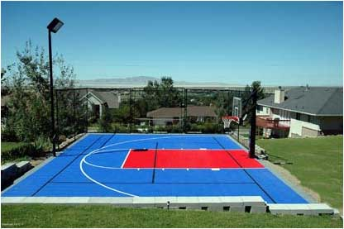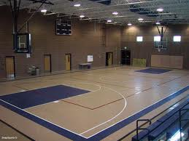
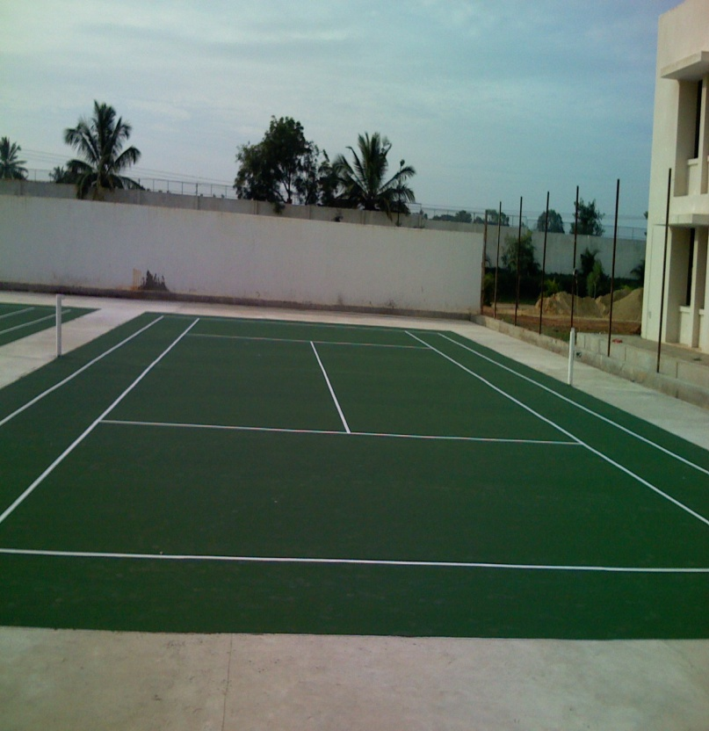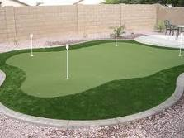
PRODUCT RANGE
BADMINTON COURT
S.NO | COMPANY | IN/OUT DOOR | TYPE OF COURT | COST IN RS
1 | SPORTSMASTER | OUT DOOR | Synthetic | Rs 96,800/-
2 | FIELD TURF TARKEET | BOTH | ARTIFICIAL GRASS | Rs 2,42,000/-
3 | FIELD TURF(SNAP SPORT) | BOTH | TILE SHOCKLOOK SYSTEM | Rs2,64,000/-
4 | L.G REXCOURT | INDOOR | FLOORING | Rs2,50,800/-

*Cost of Base Surface extra. (this work can be done by you under our supervision charges Rs. 3000 per visit)

DIMENSION OF BADMINTON COURT (20 feet by 44 feet )

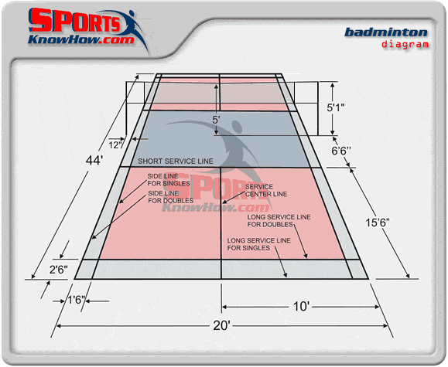
PRODUCT RANGE
TENNIS COURT
S.NO | COMPANY | IN/OUT DOOR | TYPE OF COURT | COST IN RS
1 | SPORTSMASTER | OUT DOOR | Synthetic | RS 7,92,000/-
2 | FIELD TURF | BOTH | ARTIFICIAL GRASS | RS 19,80,000/-
3 | FIELD TURF(SNAP SPORT) | BOTH | TILE SHOCKLOOK SYSTEM | RS21,60,000/-
4 | L.G REXCOURT | INDOOR | FLOORING | RS 20,52,000/-
*Cost of Base Surface extra. (this work can be done by you under our supervision charges Rs. 3000 per visit)
DIMENSION OF TENNIS COURT (60feet by 120 feet) 7200 sqft

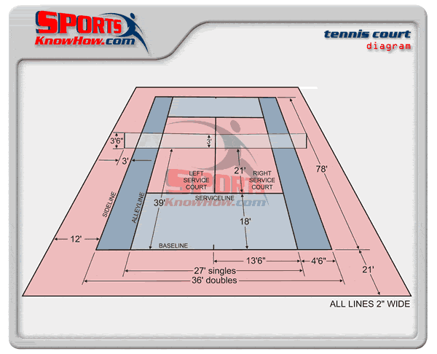

PRODUCT RANGE
VOLLEY BALL COURT
S.NO | COMPANY | IN/OUT DOOR | TYPE OF COURT | COST IN RS
1 | SPORTSMASTER | OUT DOOR | Synthetic | RS 1,98,000/-
2 | FIELD TURF | BOTH | ARTIFICIAL GRASS | RS 4,95,000/-
3 | FIELD TURF(SNAP SPORT) | BOTH | TILE SHOCKLOOK SYSTEM | RS 5,40,000/-
4 | L.G REXCOURT | INDOOR | FLOORING | RS 5,13,000/-
*Cost of Base Surface extra. (This work can be done by you under our supervision charges Rs. 3000 per visit)

DIMENSION OF VOLLEY BALL COURT (30 feet by 60 feet) 1800sqft

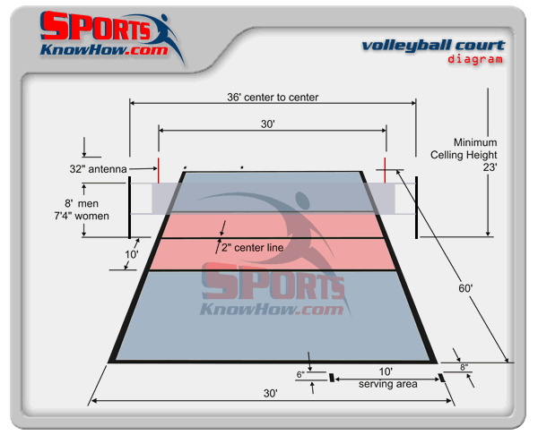
PRODUCT RANGE
BASKET BALL COURT (full court)
S.NO | COMPANY | IN/OUT DOOR | TYPE OF COURT | COST IN RS
1 | SPORTSMASTER | OUT DOOR | Synthetic | RS 5,17,000/-
2 | FIELD TURF(SNAP SPORT) | BOTH | TILE SHOCKLOOK SYSTEM | RS 14,10,000/-
3 | L.G REXCOURT | INDOOR | FLOORING | RS 13,39,500/-
*Cost of Base Surface extra. (this work can be done by you under our supervision charges Rs. 3000 per visit)

DIMENSION OF BASKET BALL COURT (94 feet by 50 feet) 4700sqft

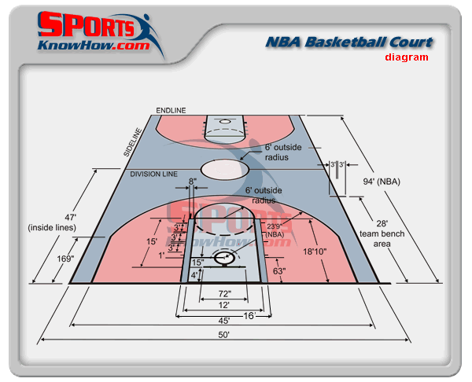

PRODUCT RANGE
golf putting green
S.NO | COMPANY | IN/OUT DOOR | TYPE OF COURT | COST IN RS
1 | FIELD TURF TARKETT | BOTH | ARTIFICIAL GRASS | ACC TO SIZE
*Cost of Base Surface extra. (this work can be done by you under our supervision charges Rs. 3000 per visit)
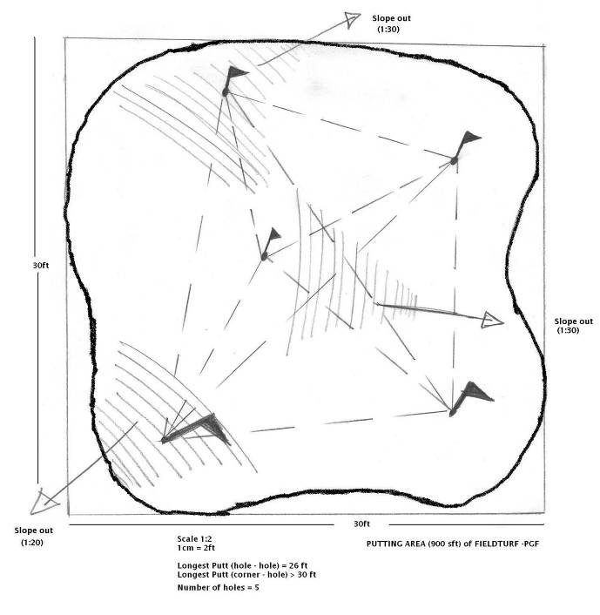

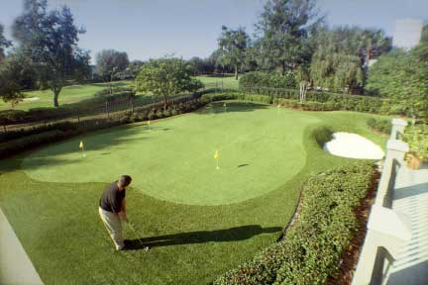
(OUTDOOR)
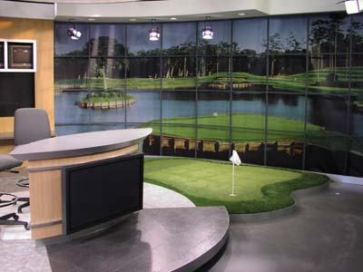
(INDOOR)
Commercials:
PGF (Putting Green FieldTurf): Rs. 550/sft
2 inch Mono (Fringe Grass) Rs. 400/sft
Signature Series for Driving Range Rs.1500/sft.
* Taxes will be charged extra as applicable.
PRODUCT RANGE
CRICKET PITCHES N OTHER
S.NO | COMPANY | IN/OUT DOOR | TYPE OF AREA | COST IN RS
1 | FIELD TURF TARKETT | BOTH | FAST PITCHES | Rs 450/PER SQFT
2 | FIELD TURF TARKETT | BOTH | SPIN PITCHES | Rs 450/ PER SQFT
3 | FIELD TURF TARKETT | BOTH | BOWLING RUN UP AREA | Rs 300/ PER SQFT
4 | FIELD TURF TARKETT | BOTH | FIELDING AREA | Rs 300/PER SQFT
Total suggested area in sft per pitch (40feet x 7`6``feet) recommended 300 sft.
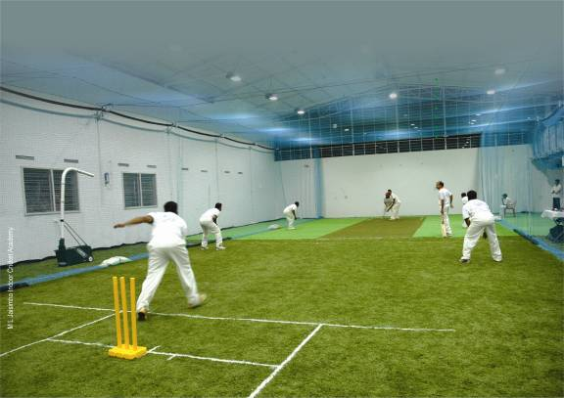
FieldTurf Bowling Run-up and Fielding area
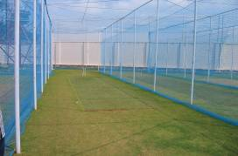
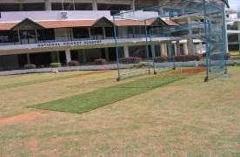 National Cricket Academy
PROMINENT CRICKET INSTALLATIONS IN INDIA
- National Cricket Academy(NCA), Bangalore- 2 Practice pitches
- Punjab Cricket Association(PCA), Mohali- 1 Practice pitch + Bowling Run-up & Fielding area
- Hyderabad Cricket Association(HCA), Hyderabad- 2 Practice pitches
- Goa Cricket Association (GCA), Mapusa, Margaon, Purvorim, Vasco. Each with 2 Practice pitches + bowling run-up area
- Orissa Cricket Association(OCA)Cuttack- 2 Practice pitches
- Andhra Cricket Association, Vijayawada- 31 Practice pitches
- M L Jaisimha Indoor Cricket Academy, Hyderabad- 1 Practice pitch + bowling run-up area + 4,000 sft of fielding area.
- Vidarbha Cricket Association: 2 Practice pitches + bowling run-up & fielding area
- Maharaja Sawai Mansingh Vidhyalaya, Jaipur- 4 Practice pitches
- Headstart, Bangalore- 1 Practice Pitch
- Indian Army, Hyderabad- 1 Practice Pitch
- Jain International School, Bangalore- 2 Practice Pitches

PGF SPECIAL CRICKET PITCH
- Unique Characteristics:
  - 30mm Fibre (vs. 10mm)
  - Fibre direction:
    - Fast Bowling
    - Spin Bowling
  - Extremely Long life
    - Eg: MLJ: 4+ Years and as good as new!

Benefits of the FieldTurf system
- All the bio-mechanical properties of natural grass
- Virtually NO maintenance
- Prolong players’ careers
  - No repetitive stress-injuries on ankles, knees, back etc.
- Practice sliding / diving stops right from initial days
- 365 days; 24*7 practice time

- Synthetic COURT’S

SPORTSMASTER ULTRA CUSHIONED SYSTEM – 8 LAYERS
No. of Courts Price
- Rs. 110 per Sqft + VAT

In this system we shall apply 1 layer of resurfacer, 5 layers of cushion, 2 layers of color and court markings. This is ultimate in cushion comfort greatly enhances players comfort and considerably minimizes fatigue and injury due to fall.
asphalt BASE
The synthetic surface is laid over an asphalt base which is prepared as per the specifications given here below.
The specifications of construction are as follows

Base Surface - A typical asphalt base consists of a 8” inch pavement which consists of :
- Excavation to a depth between 6 to 8” or as required to remove all weeds and grass from its roots, create a slope of 1” in every 10’ in the sub-base on the shorter axis, backfill with good earth as required (without any grass or weeds). Extreme care would need to be taken to ensure a correct slope of 1” in every 10’.
- Compaction of the sub-base will be by 8 – 10 ton roller.
- Carry out anti termite and weedicide on the total area by making 9” deep holes spaced 12” apart and injecting the chemicals and also spraying.
- Lay a 1st layer of 3” compacted water bound macadam. WBM to be densely compacted by keying and interlocking the stones to ensure no settlement takes place.
- Lay a 2nd layer of water bound macadam (3 inches thick) same as above except the stone size will be smaller.
- Lay a 30mm compacted thick Hot Mix asphalt BM course.
- Lay a 20mm compacted thick Hot Mix A.C. course
- Seal Coat with stone dust.
- An open saucer drain at the lower end

Edge Wall - Laying a retaining wall flush with the ground

Price Includes:
- Import Duty
- C.I.F values
- Installation Charges
- Custom Clearance

Synthetic COURT’S

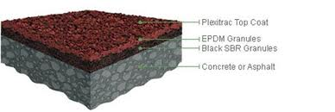

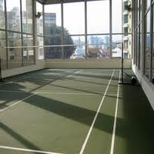
2. FIELD TURF GRASS COURT’S

FIELD TURF ARTIFICAIL GRASS COURT Rs 325 /350/475/- PER SQFT
MULTI SPORTS ARTIFICAIL GRASS FROM AMERICA
WWW.FIELDTURFINDIA.COM

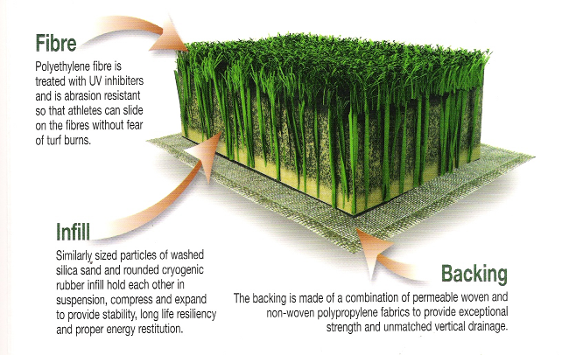

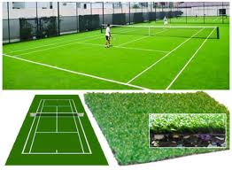
3. FIELD TURF (SNAP SPORT)
FIELD TURF (SNAP SPORT) COURT’S Rs 300/- PER SQFT WITH SHOCKLOCK SYSTEM
WWW.SNAPSPORTS.COM

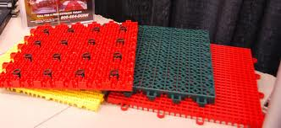

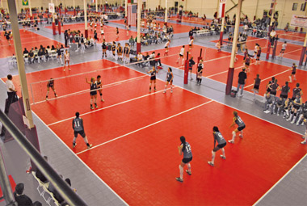

4. L.G REXCOURT INDOOR FLOORING SYSTEM
L.G REXCOURT INDOOR FLOORING SYSTEM Rs 285/- PER SQFT

